# CREATE A SOCIAL MEDIA POST

INTRODUCTION

OVERVIEW

A SOCIAL MEDIA MARKETING STRATEGY IS A SUMMARY OF EVERTHING YOUPLAN TO DO AND HOPE TO ACHIEVE ON SOCIAL MEDIA. IT GUIDES YOUR ACTIONS AND LETS YOU KNOW WHETHER YOU’RE SUCCEEDING OR FAILING.

THE MORE SPECIFIC YOUR PLAN IS THE MORE EFFECTIVE IT WILL BE. KEEP IT CONCISE. DON’T MAKE IT SO LOFTY AND BROAD THAT ITS UNATTAINABLE OR IMPOSSIBLE TO MEASURE.

PURPOSE

THE MAIN PURPOSE OF SOCIAL MEDIA POSTS IS TO INCREASE BRAND AWARNESS AND VISIBILITY.THE MORE PEOPLE KNOW ABOUT YOUR SOCIAL PRESENCE,THE MORE PEOPLE YOU CAN POTENTIALLY TURN INTO CUSTOMERS. SOCIAL MEDIA POST’S ALSO HELP IN BUILDING RELATIONSHIPS WITH YOUR AUDIENCE WHEN THEY ENGAGE WITH YOUR POSTS.

PROBLEM DEFINITION & DESIGNING THINKING:

EMPATHY MAP:

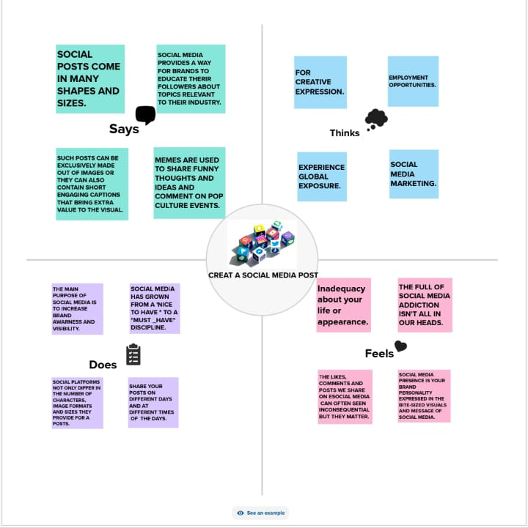

IDEATION & BRAINSTORMING:

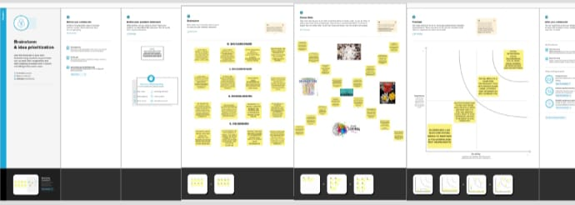

ADVANTAGES AND DISADVANTAGES:

FIRST ON OUR LIST OF SOCIAL MEDIA BENEFITS IS THAT YOU CAN REACH LARGE AUDIENCES. THERE ARE MILLIONS OF PEOPLE USING SOCIAL MEDIA PLATFORMS. IT’S A GREAT OPPORTUNITY FORYOUR BUSSINESS TO REACH A LARGE POOL OF PEOPLE THAT ARE INTERESTED IN YOUR PRODUCTS OR SERVICES.

ACCORDING TO PEW RESEARCH CENTRE THESE ARE THE PERCENTAGES OF U.S. ADULTS THAT USE SOCIAL MEDIA SITES ONLINE OR ON MOBILE.

DISADVANTAGES:

WITH ANY MARKETING STRATEGY, THERE ARE ALWAYS DISADVANTAGES. THE DISADVANTAGES DON’T MEAN THAT THE APPROCH ISN’T EFFECTIVE, BUT RATHER, PRESENT POTENTIAL HURDLES YOU MAY HAVE TO JUMP THROUGH DURING YOUR CAMPAIGN.

APPLICATION:

IN THIS POST, WE’LL WALK YOU THROUGH A NINE STEP PLAN TO CREATE A WINNING SOCIAL MEDIA STRATEGY OF YOUR OWM. WE’VE EVEN GOT EXPERT INSIGHTS FROM AMANDA WOOD, HOOTSITE’S SENIOR MANAGER OF SOCIAL MARKETING.

CONCLUSION:

THE EFFECTS FROM SOCIAL MEDIA ARE VERY COMPLEX AND VERY FROM PERSON TO PERSON. BASED ON OUR DATA WE FOUND THAT MANY PEOPLE EITHER EXPERIENCE NEGATIVE EFFECTS OR NOTICE THEM IN OTHER PEOPLE.